### Step 1: Add homepage to package.json[#](https://create-react-app.dev/docs/deployment/" \l "step-1-add-homepage-to-packagejson" \o "Direct link to heading)

Open your package.json and add a homepage field for your project:

"homepage": "https://myusername.github.io/my-app",

or for a GitHub user page:

"homepage": "https://myusername.github.io",

or for a custom domain page:

"homepage": "https://mywebsite.com",

Create React App uses the homepage field to determine the root URL in the built HTML file.

**Step 2: Install gh-pages and add deploy to scripts in package.json[#](https://create-react-app.dev/docs/deployment/" \l "step-2-install-gh-pages-and-add-deploy-to-scripts-in-packagejson" \o "Direct link to heading)**

Now, whenever you run npm run build, you will see a cheat sheet with instructions on how to deploy to GitHub Pages.

To publish it at <https://myusername.github.io/my-app>, run:

npm install --save gh-pages

Alternatively you may use yarn:

yarn add gh-pages

Add the following scripts in your package.json:

"scripts": {

+ "predeploy": "npm run build",

+ "deploy": "gh-pages -d build",

"start": "react-scripts start",

"build": "react-scripts build",

The predeploy script will run automatically before deploy is run.

If you are deploying to a GitHub user page instead of a project page you'll need to make one additional modification:

1. Tweak your package.json scripts to push deployments to **master**:

"scripts": {

"predeploy": "npm run build",

- "deploy": "gh-pages -d build",

+ "deploy": "gh-pages -b master -d build",

**Step 3: Deploy the site by running npm run deploy**[**#**](https://create-react-app.dev/docs/deployment/#step-3-deploy-the-site-by-running-npm-run-deploy)

Then run:

npm run deploy

**Step 4: For a project page, ensure your project’s settings use gh-pages**[**#**](https://create-react-app.dev/docs/deployment/#step-4-for-a-project-page-ensure-your-projects-settings-use-gh-pages)

Finally, make sure **GitHub Pages** option in your GitHub project settings is set to use the gh-pages branch:

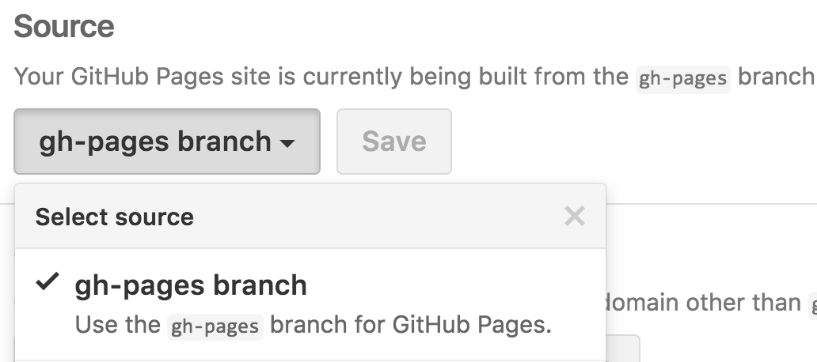

**Step 5: Optionally, configure the domain**[**#**](https://create-react-app.dev/docs/deployment/#step-5-optionally-configure-the-domain)

You can configure a custom domain with GitHub Pages by adding a CNAME file to the public/ folder.

Your CNAME file should look like this:

mywebsite.com